WAREHOUSE ROUND UP
The goal is to have an in-house meeting to test all the system functions on Wednesday August 5 with all updates done before we have all warehouse inventory in the system by August 14 & 15 2026.
7/30/26: REVIEW OF ALL FUNCTIONS (requested changes and updates)
Important – change everything wording in the system that says stock to just say inventory. (we refer to inventory and stock as the same thing) e.g. Stock control changes to just inventory control.
Cost value change all to just Cost (we refer to values as just cost)
The back buttons are not added to all the tabs that are needed for. Please check and fix
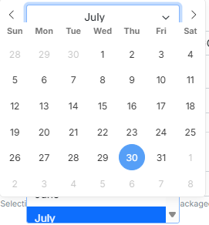
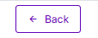
The date filters are not working correctly

- Warehouse
- My warehouse (:
- Stock & inventory (Inventory movement): make the stock adjustment (inventory adjustment) and stock in purchase (inventory in purchase) accessible by ADMIN access only that is when the system goes live. (current inventory quantity)
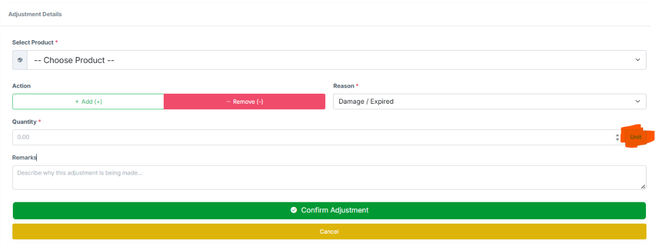
- Adjustment can either be done by the quantity > case/box or the quantity > unit (individual items). In a case (reason) when only 1 item in the case/box is damaged/or theft It can be adjusted.
- Products
- All products (:
- + add new product (:
- Promotions: the promotion you have set up in the store’s railway system is what should be here and can be linked to select different markets
- Category / Sub-category / Department (:
- Market (:
- Market pricing: the market cost and selling price are wrong. It should be the Warehouse Price (WHSE Price) and the Store Retail Price or Manual Override Price.
- Procurement
- Vendors (:
- Purchase orders: After the email has been sent for approval, the person by mistake approves the order, and then goes back again to reject it, that order should go back to draft to either > sending for approval/cancel order/ edit po
- Receiving orders: Vendors invoice numbers stop showing while still receiving products and after the receipt is complete it needs to stay on like the duties and the shipping stays on the print receipt and the QTY is still missing from the printed receipt.
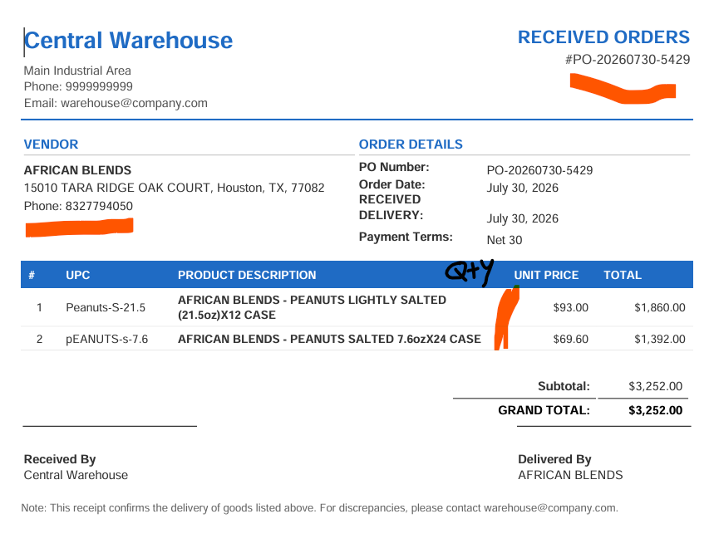
- Completed orders: order summary needs to reference the vendors invoice number.
- Store orders: similar to PO order > completed orders process is set up, that is what we want for the stores orders.
- Store orders (PO): The process …
FILTER: Store Location and Date
Po number > Store Location > Date > Items order (general total for all departments) > Status (Pending Po & approved) > Action
Action: opening up the store –selects department (in department) filter by > category.
Pending PO: here the warehouse purchasing manager opens the store po
FILTER: Department and Categories (because the store places orders by department)
Still on pending PO: the purchasing manager has opened the po and clicks on the department (filter by categories) to look through the items ordered and then APPROVES the store’s PO.
Approved PO: here warehouse manager can select the store po that they are currently working on and select the various departments and categories in that store they are assigned to.
Po number > Store Location > Date > Items order (general total for all departments) > Status (incomplete, processing and complete) > pallet builder (Ready or in Process) > Action
Action: opening up the store –selects department (in department) filter by > category.
Upc > Product> Whse Price > Whse Qty > Requested Qty > Sent Qty
If all items are in stock – click complete (sending all qty) and Move on to the next category
If most items are low in stock, the system should compare between the different stores that have requested the product and share it according to the stores min-max levels - then it is recorded as/in Transfer Shortage.
While working on the store PO >department>category allows save progress (save draft and allow editing the products quantity + / -). Until all categories are department are completed
Print out the category completed (on paper only Date > Stores Names > UPC > Product > Whse qty > Sent Qty) papers are for warehouse staff and should not include the product price, this paper will be used manually for pallet builder until the system automatically calculates the appropriate weights and does that.
Print PO by each department/category selected with name of the store, date of po, UPC code of the products, quantity ordered and quantity sent
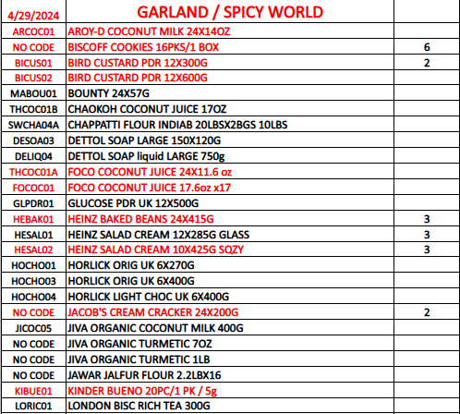
(This is the way our current Store PO order sheet looks like, it needs to look better and more organized. Right now, we only have date (under that we have the upc codes) > store name/categories > Qty ordered). XXXX
After all the category is completed and pallet builder is Ready, the warehouse manager clicks to open the store PO and checks that all the department is completed then clicks on a button SEND TO DISPATCH.
Dispatch / in transit: Dispatch- order is on its way to the store, In transit- store is actively receiving that order. When the store completes their receiving process then it moves to completed store order. (t
Po number > Store Location > Date > Items ordered > items sent > Status (Dispatch or In transit) > Action
Action: opening up the store -filter: selects department
Print Pallet manifest (shortcut)
Rejected: Reason for rejecting the Store po
Completed Stores PO (Replacing discrepancy): all completed store po, Transfer Shortage store po moves here
FILTER: completed/ Transfer Shortage And Date
Po number > Store Location > Date > Items ordered > items sent > Status (completed / Transfer Shortage) > Action
Action: reason for Transfer Shortage.
- Legacy orders (change name to Stores Request): this can allow the stores to request few products in a case where after their store po orders they run out of inventory earlier than expected and need some more.
Pending > In transit (where it would be linked to a pallet builder) > History
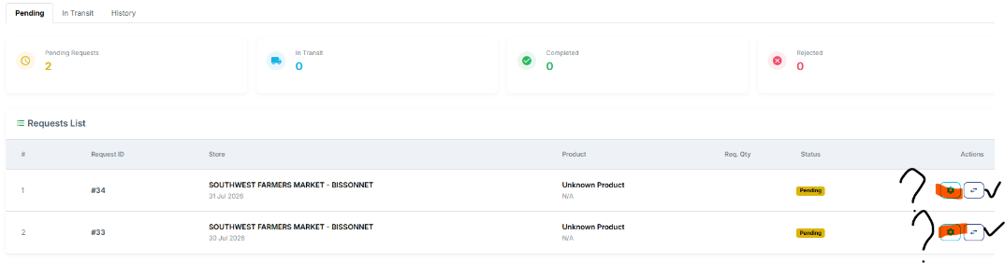
- Discrepancy (take it out): Transfer shortage is moved Completed stores po and store returns are already recorded in Recall stock.
Stock control (Inventory Control):
Example: we have a 24-bottle case of drink product and only 6 are damaged/broken that remaining 18 bottle is also sent to the stores how do we account for those unit/ea bottles we have in inventory and when we send them to the stores.
- Stock overview: can this example be implemented here. Product > upc > department > category > subcategory > whse case qty > whse unit qty (from recorded adjustment by unit)
- Warehouse Repackaging: search button is not convent, after a product as been selected for repacking it cannot be added twice in a roll.
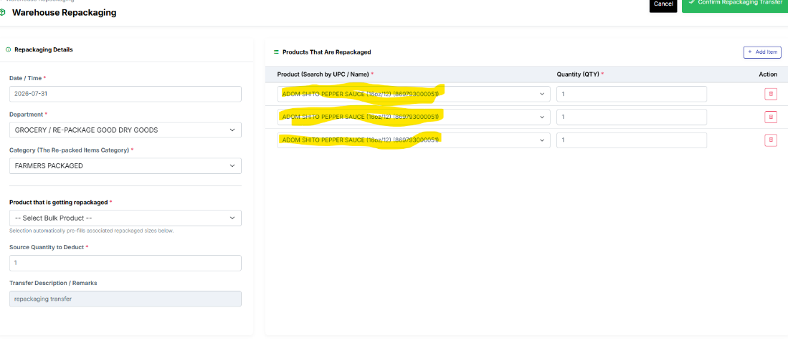
Preferred search bar is the “stores railway system” order inventory search bar, the way it is set up.
- Transfer: add a filter by Date.
- Recall: The date filter is not working correctly.
Stock valuation: The search bar doesn’t work correctly
Product > UPC > Department > whse qty > whse product cost or whse cost > whse total value.
WHSE Analytics: Action
Warehouse batch (PO orders): Batch no (order no) > Expiry > Total (as in cost value the product was bought for) > qty
Recent transactions: should only be based on the WHSE activities.
STORE Analytics: Action
Warehouse batch (PO orders): Batch no (order no) > Expiry > Total (as in cost value the product was bought for) > qty

Recent transactions: should only be based on the STORES activities. (the stores PO, stores transfer and when the stores sell the product (-10 on Qty change)
Question: is store distribution stock specific to the store that was selected?

- Inventory count: is not working (error 500)
- Free weight (:
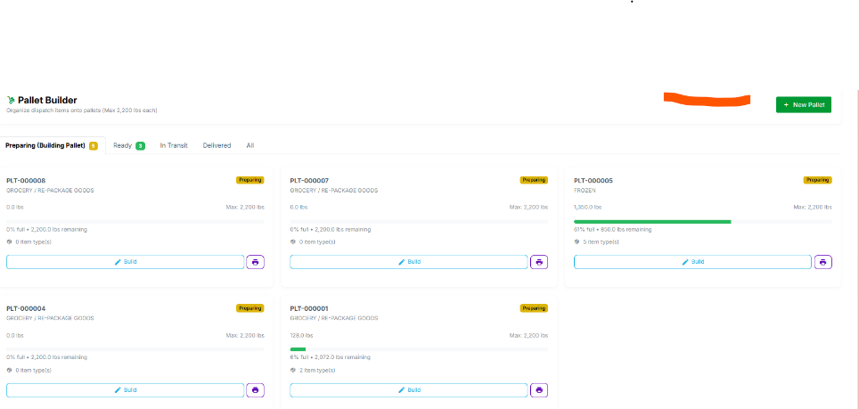
- Pallet builder: I haven’t been able to test it out all the way seeing as they are no created store po to link it. Date filter
The idea for pallet builder: after a stores PO is created and linked to a + New pallet builder the system lets the warehouse staff know which product to put together on the pallet based on the weight and length of the product.
That why
“Print out the category completed (on paper only Date > Stores Names > UPC > Product > Whse qty > Sent Qty) papers are for warehouse staff and should not include the product price, this paper will be used manually for pallet builder until the system automatically calculates the appropriate weights and does that.”
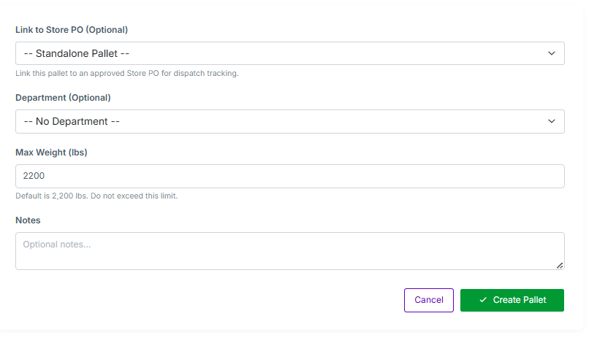
Link store PO or Link stores request (two separate things): it should either link it to a store general PO order or just a few products requested.
Department is not optional it is needed because when the stores PO are linked then you have to select the department you are currently building a pallet for.
- Restock planning (change mane to Inventory Planning): Print forecast function is not working correctly. The search bar also isn’t working correctly; I can’t search through upc codes.
Adequate Stock (Adequate Inventory)
Question: is this where we find out what the last cost of the product was purchased for? If not, where do we find out?

